**This work (file, document) is licensed under the Creative Commons Attribution-NonCommercial 4.0 International License. To view a copy of this license, visit http://creativecommons.org/licenses/by-nc/4.0/.**

**Date of creation: January 2015 - July 2015 and Attribution: Prasad N R as a representative of (unregistered) company TraQuad.**

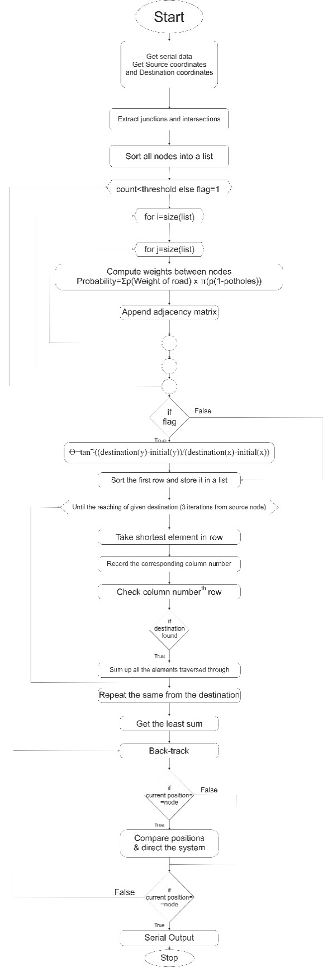

**Figure: Flowchart of the software implementation**

The source and the destination coordinates desired are input. Then, this path planning algorithm computes the shortest path and gives the directions consistently evaluating the current position.

In the recording mode, the data is serially input and the map is recorded as a matrix.

In the driver assist mode, the information about the junctions and intersections are extracted. Sorting is done so as to ease the process of path planning. A counter is also used to prevent infinite looping or even bricking if used on some other hardware. Then, possible permutations and combinations are performed between two nodes. The effective distance between the given pair of nodes is calculated with probabilistic and logical operations. This effective distance is fed to the adjacency_matrix.

In case there exists no path practically, then, the assist system would point out to the direction considering the current location and the destination. This happens when the path is not obtained within the set number of iterations.

The parameter rough_smooth in the code can be used to optimize the path with respect to distance or time. With thegiven weighted graph, three shortest paths are taken up from source node and three from destination node. All the six paths are evaluated and the one generating the least sum is taken up as the one with shortest distance heuristically. This is our algorithm which has reduced brute-force code taking up O($n^{2}$) to O(n). This type of reduction finds applications in real-time critical implementations.

The current position is evaluated with to send out the commands regarding the movement.

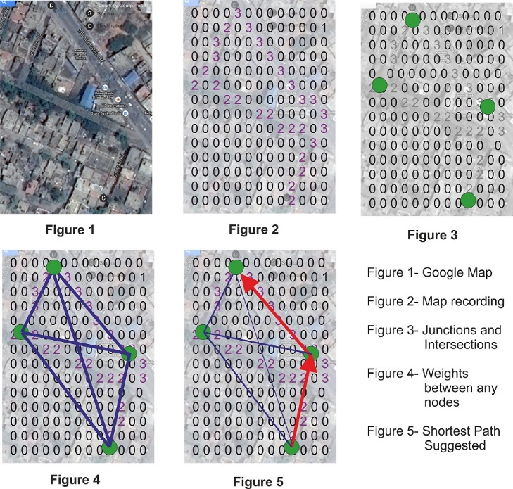

**Figure: Working of the algorithm**

A paper on this software titled “Normal probability and heuristics based path planning and navigation system for mapped roads” has been authored by the author (the code belongs to the author while the paper has been published by four other authors as well) and it is about to be published soon; The link of the article shall be documented as soon as it is published.